Practical No 2
Installation of Oracle VirtualBox and Ubuntu Linux Virtual
Machine
Aim: To install Oracle VirtualBox and create an Ubuntu Linux Virtual Machine.

Learning Objectives
- Understand virtualization
- Install Oracle VirtualBox
- Create/configure VM
- Install Ubuntu
- Verify installation

Prerequisites
- 8 GB RAM (16 GB recommended)
- 40 GB free space
- Windows 10/11
- Oracle VirtualBox
- Ubuntu Desktop ISO

Theory
- Virtualization allows multiple operating systems to run on one physical computer using virtual machines.
- Oracle VirtualBox is a Type-2 hypervisor.

Procedure

(Screenshots):

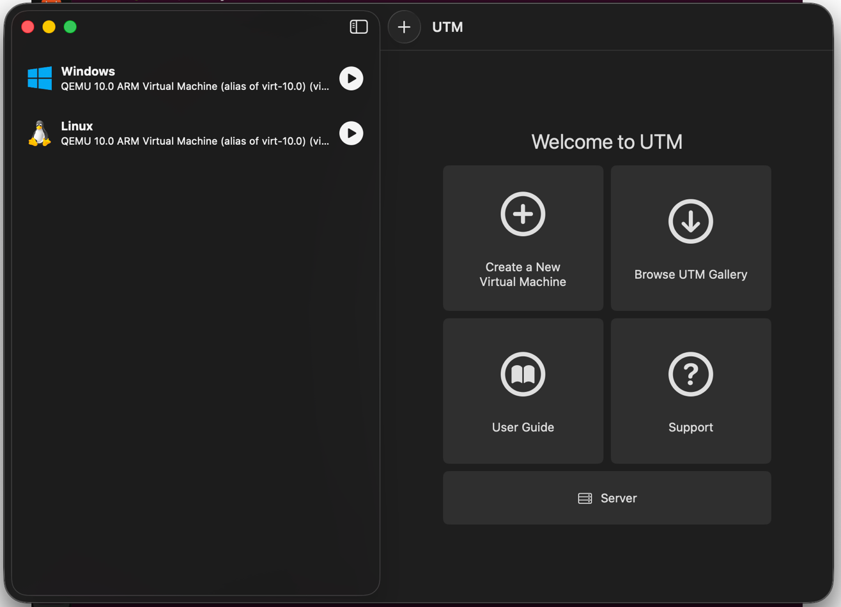

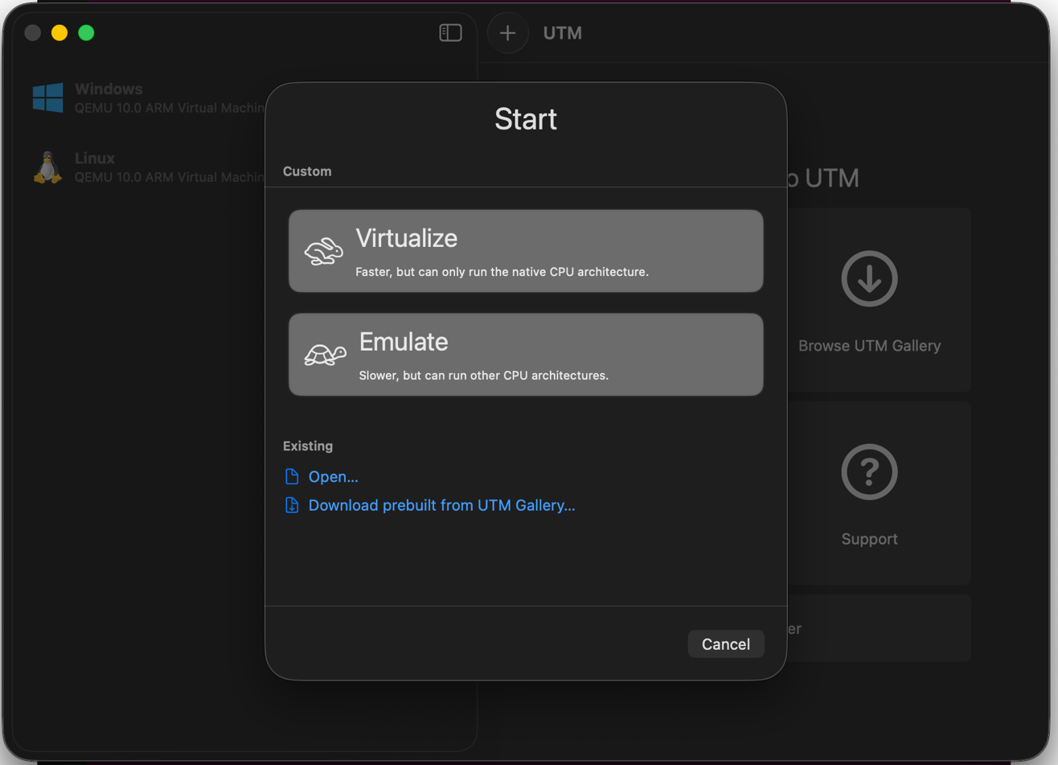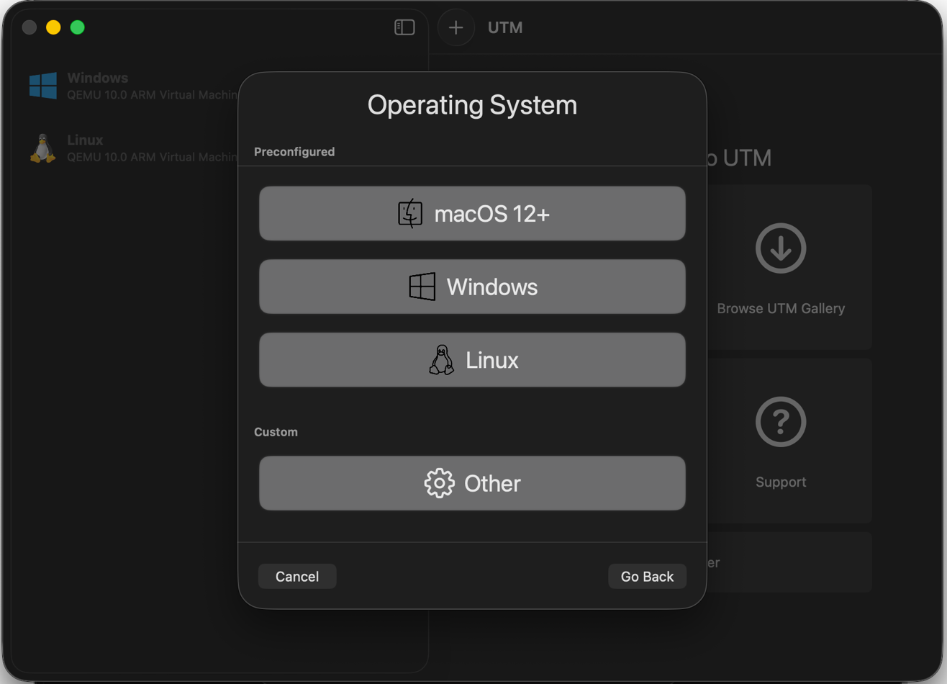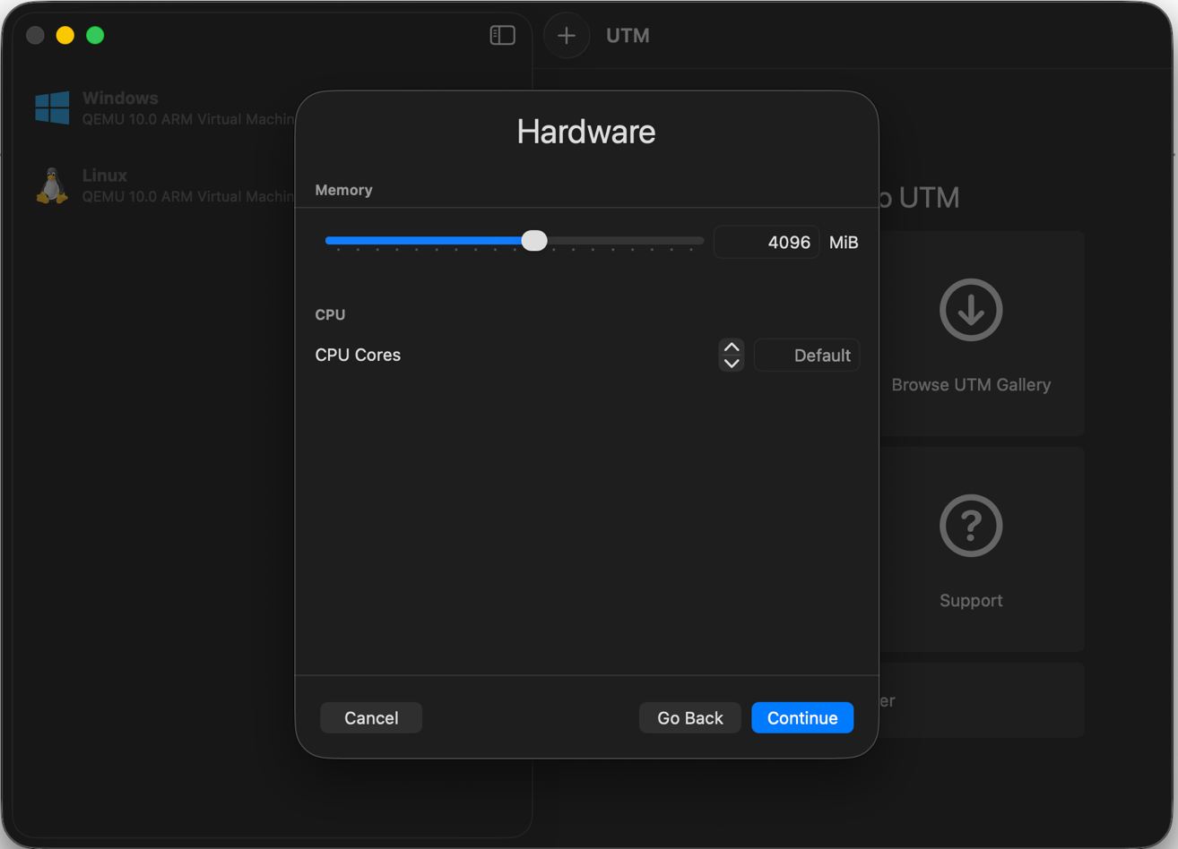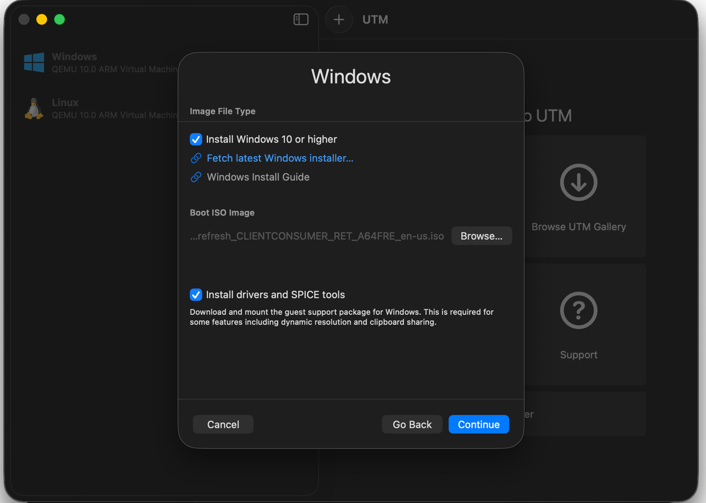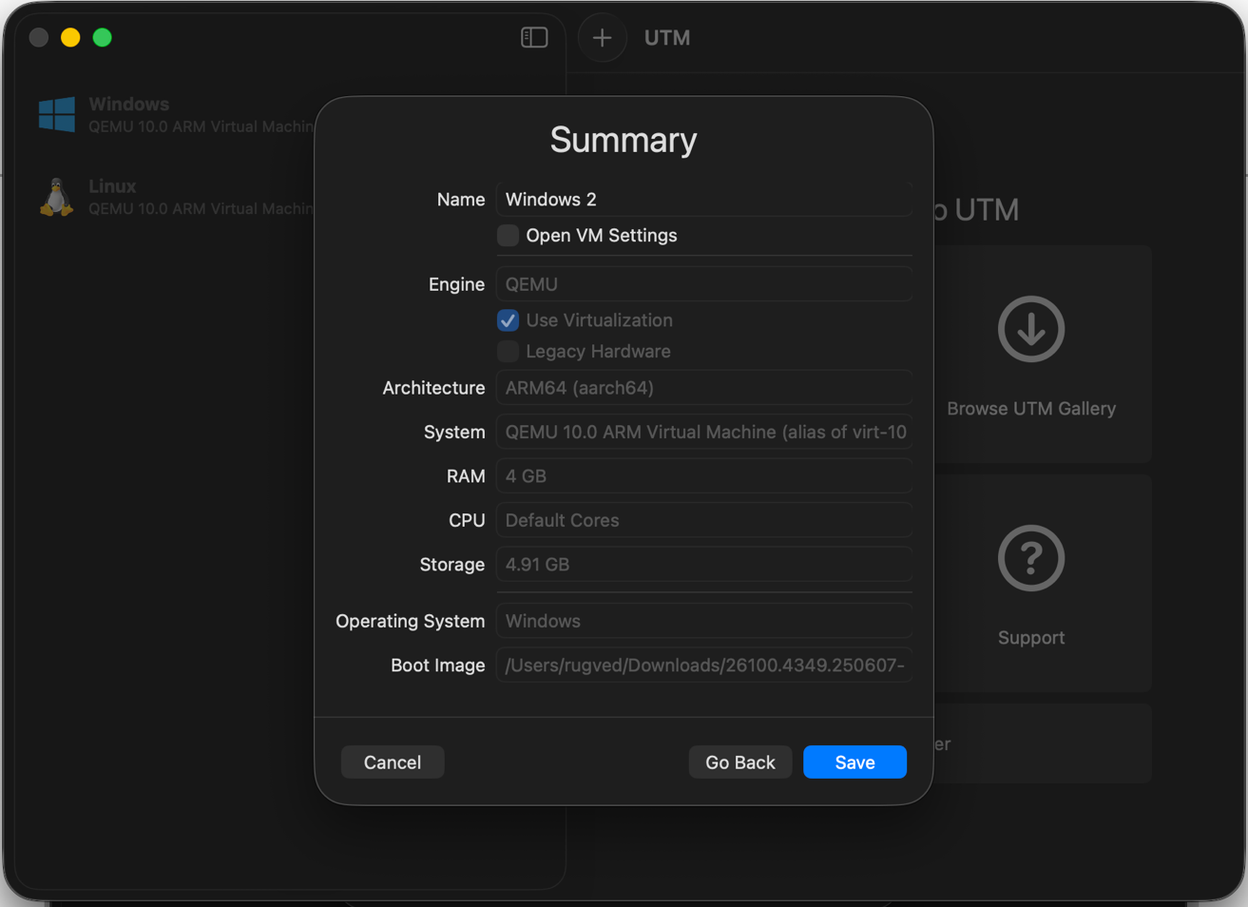
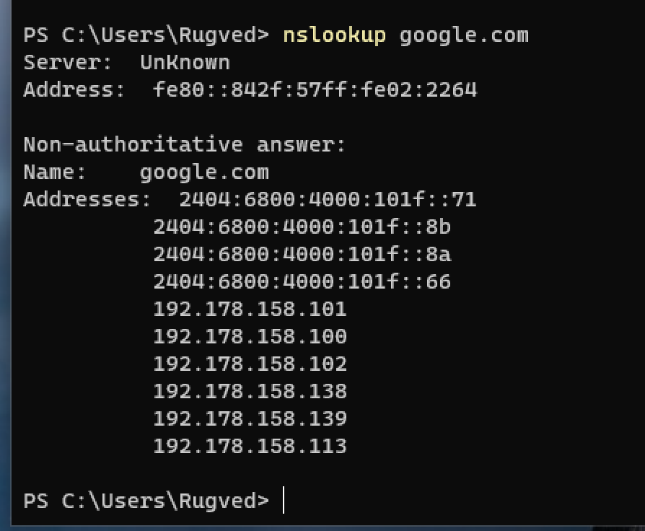
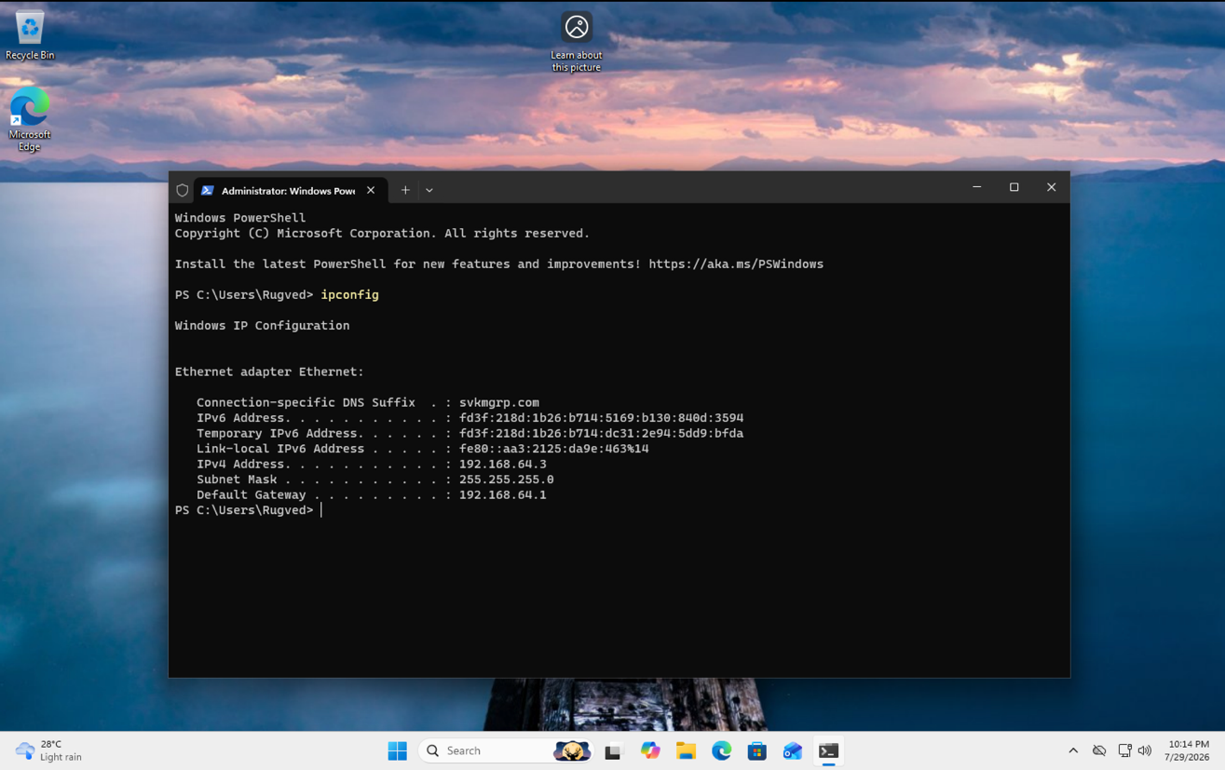
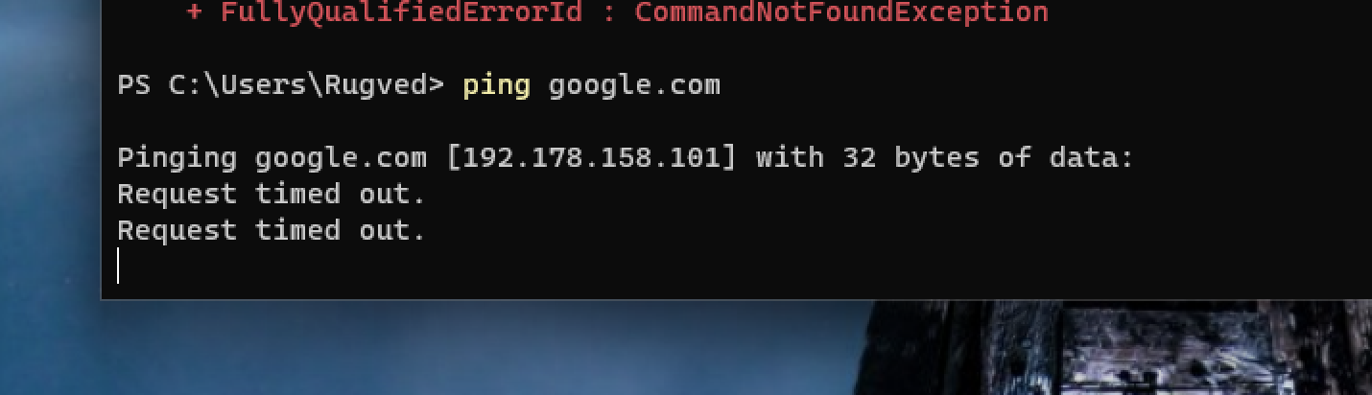
- Install Oracle VirtualBox.
- Download Ubuntu Desktop ISO.
- Create VM: Name Ubuntu-Lab, Linux/Ubuntu 64-bit, 4096 MB RAM, 2 CPUs, 25 GB dynamically allocated VDI.
- Attach Ubuntu ISO under Storage.
- Start VM and install Ubuntu using default options.
- Create a user account and restart after installation.
- Verify installation using terminal commands: lsb_release -a, uname -r, whoami, hostname, df -h, free -h.

Expected Outcome
- Ubuntu VM boots successfully.
- Basic Linux commands execute correctly.

Conclusion:
We conclude from the above experiment that to create and run a virtual machine, first we need a platform that allows us to run it, which in our case was UTM. After installing UTM, we installed Windows as the operating system for our virtual machine. We also had to allocate some resources from our physical machine such as RAM, storage and processor cores so that Windows could run smoothly. After launching the virtual machine, we had to set up Windows just like we do on a new computer by selecting the basic settings and creating a user account. Once the setup was completed, the Windows virtual machine was ready to use. From this experiment, we learnt how Windows can be installed and operated virtually using UTM and how a virtual machine uses the resources of our physical machine to run.

